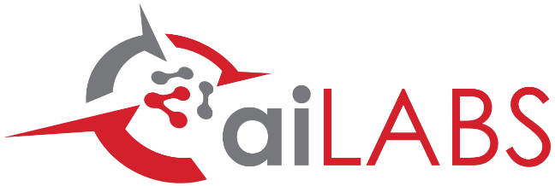

**ORbital Wargame in GEO**

Primary POC: Luke Schoenwetter

Primary Business Stakeholder: Mike Mason

**SMART GOAL**

Demonstrate to senior National Space Test and Training Complex (NSTTC) officers a wargame that accurately models the information, choices, and outcomes available to a geosynchronous spacecraft operator during a Rendezvous and Proximity Operation (RPO) by an adversarial spacecraft.

**Map to business value**

The aiLabs Innovation Target that supports this request is: Interactive Orbital Warfare Training. The target customer is the USSF NSTTC. Additionally, this initiative would expand our current USSF training beachhead beyond ObsSIM and JCO Sensor Calibration support.

**OVERVIEW**

In October 2022, the USSF released a document outlining the vision for NSTTC which specifically calls for an orbital Red vs Blue modeling and simulation environment. Talks by senior USSF officers at the 2023 Space Symposium indicated the USSF’s intent to secure funding for various NSTTC objectives. This aiLabs initiative will result in a demonstratable wargame capability (powered by FreeFlyer) which will act as a springboard for a.i. solutions to bid on future USSF contracts.

**Resources**

Project Duration: *2 months*

Proposed Start Date: *7/10/2023*

Proposed End Date: *9/11/2023*

Need-By Date (if applicable to business need):

*9/11/2023 for demo at AMOS conference*

**Staff**

|  |  |
| --- | --- |
| **Team Member** | **Allocation (%)** |
| *Luke Schoenwetter* | *25%* |

**Direct Costs**

|  |  |
| --- | --- |
| **Item** | **Cost ($)** |
| *N/A* | *$0* |
| *Total* | *$0* |

**TOTAL COST**

|  |
| --- |
| *$8,300* |

**Past Relevant Experience**

The team has a research-based background in applied game theory and adversarial spacecraft encounters as well as the history of anti-satellite tactics. (L. Schoenwetter, *Game Theory Applications in Astrodynamics and Space Domain Awareness*, Master’s thesis, The University of Alabama, August 2021)

**ROI POTENTIAL**

Substantial potential exists for return in the form of software sales / support and brand name recognition. The 2024 USSF budget proposal dedicates $340m to an “operational testing and training infrastructure”. Also, the USSF stated at the 38th Space Symposium that “There are some areas where we absolutely need help from the industry” when it comes to manifesting the NSTTC. In the long term, securing a contract for building a more extensive wargame suite would give our flagship software a huge name recognition boost inside of USSF.

**IMPACT IF NOT DONE**

NSTTC is an opportunity to be on the leading edge of an emerging technological arena. To our knowledge, no company is currently able to offer the modeling and simulation capabilities needed. That being said, other space companies will absolutely jump on this opportunity. Once we fall behind our competitors, the opportunity is severely diminished.